**SPOT EXERCISE**

P.PRIYADHARSHINI

2019103562

22-02-2021

1.to know who is logged on to this and other systems

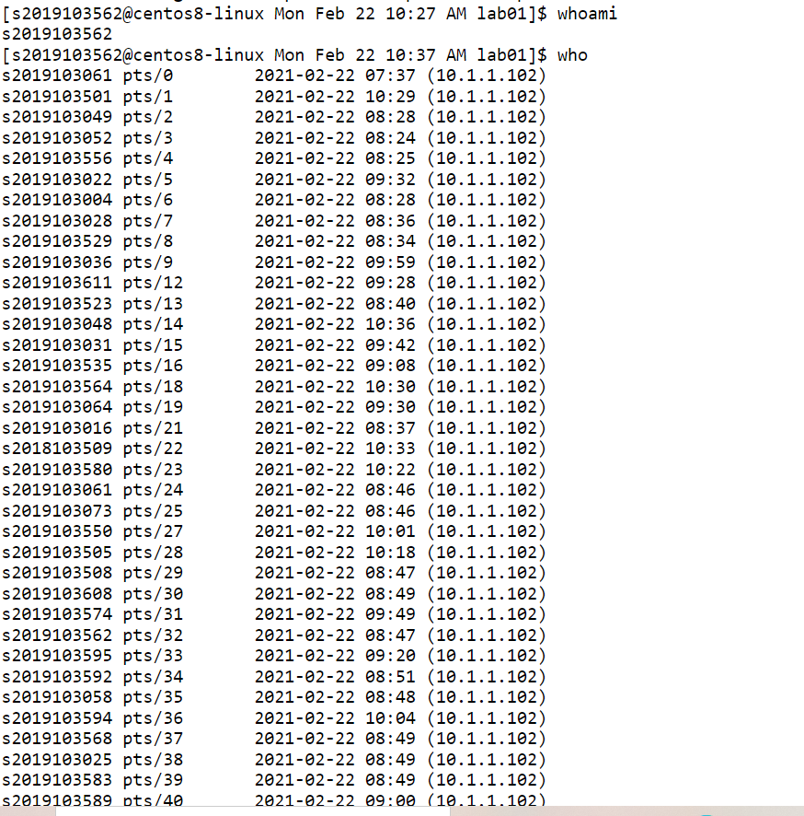

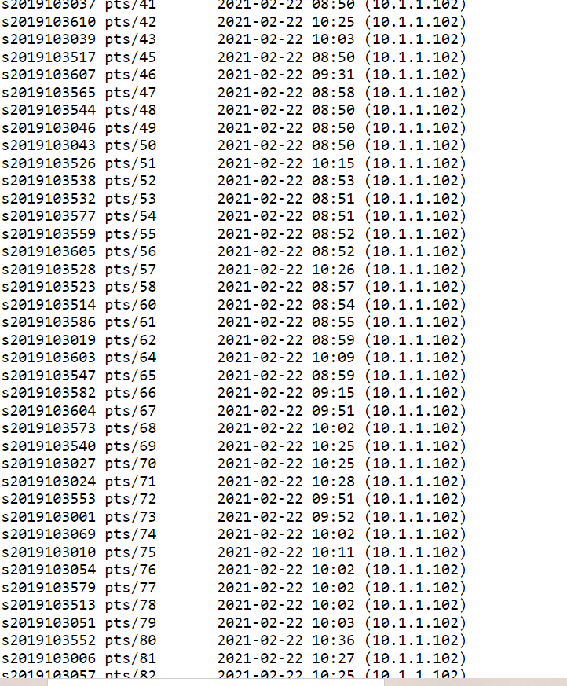

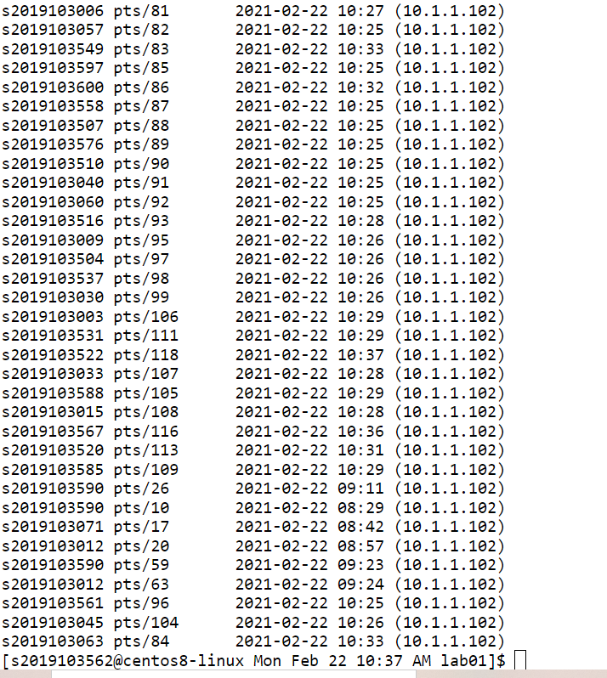

2.to learn details about a particular command

Man command

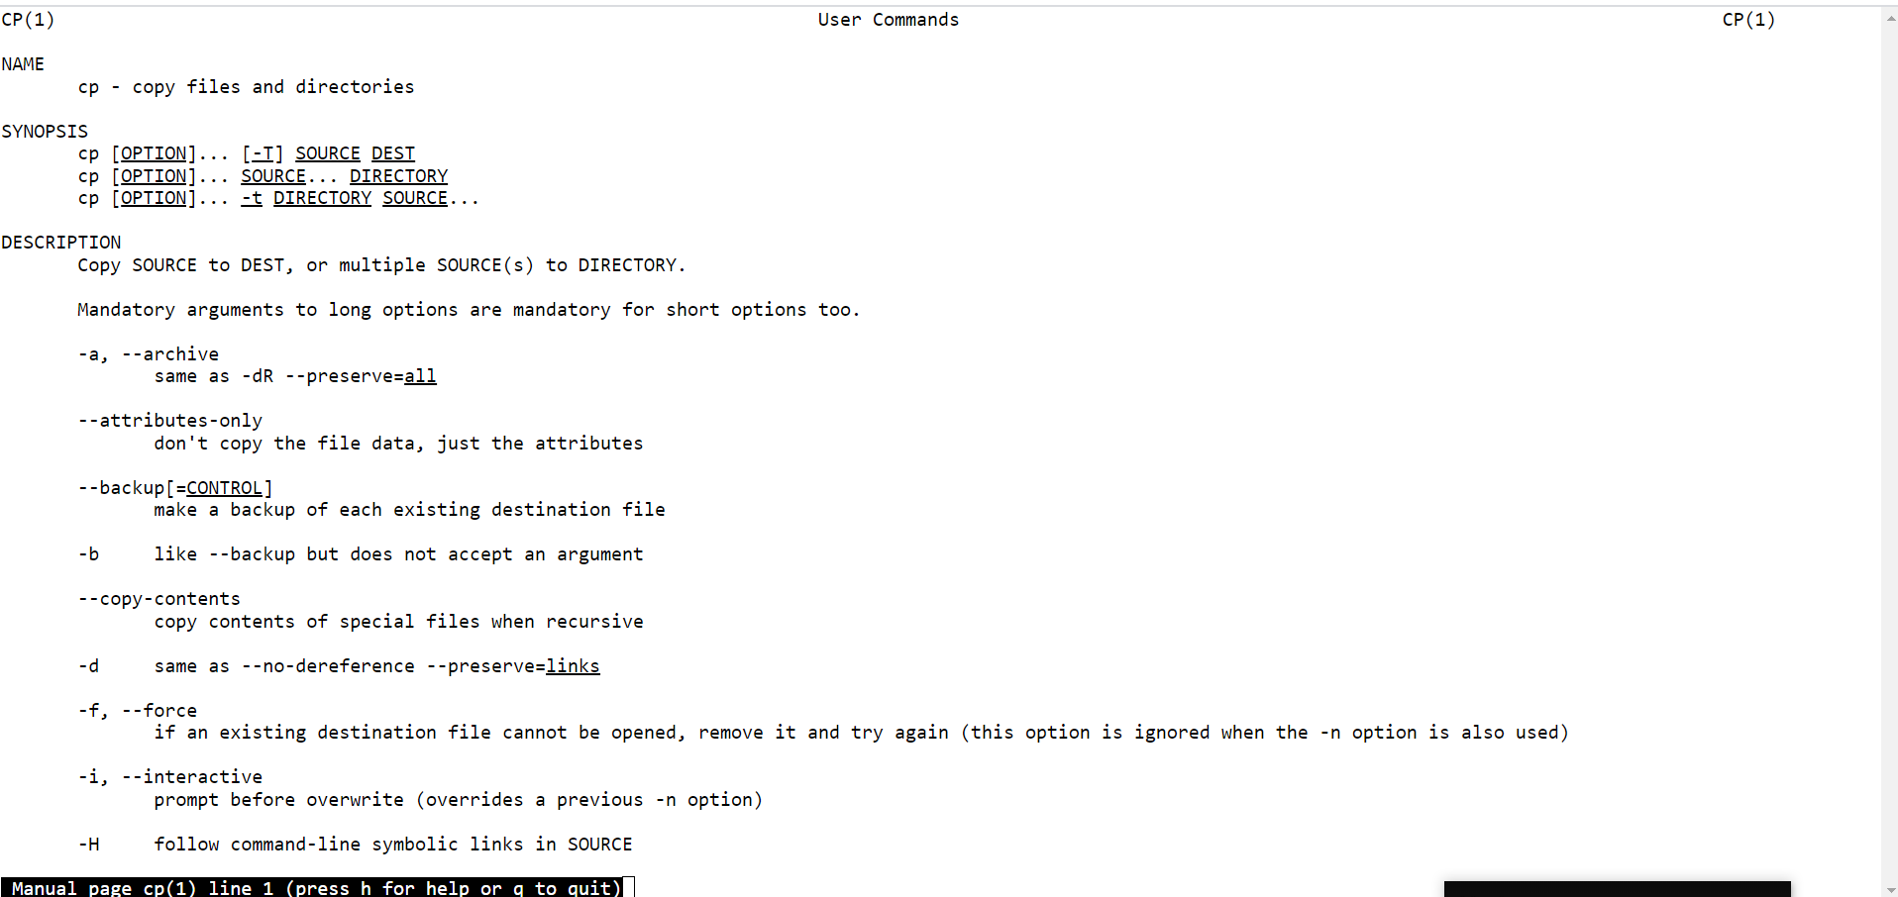

3.to list the last 6 lines of a file

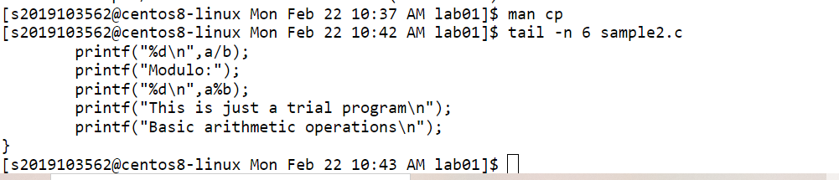

4.to delete directories and their contents

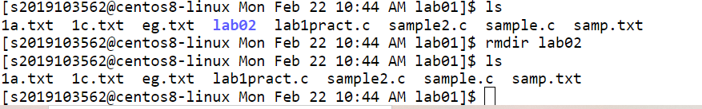

5.to create a blank new file

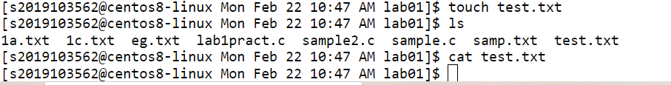

6.to display the list of running process and their resource usage



7.to move a file from your current working directory to root

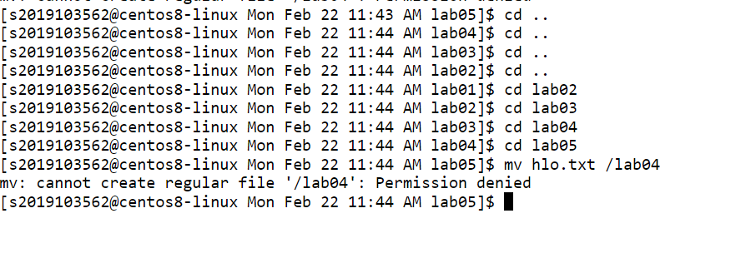

8.to move information from command line to a file

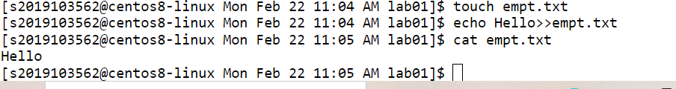

9.to check the connectivity of a server



10. To change a file’s mode to read, write and executable mode.

